Name:Hemant Narendra Khankari

Roll No: 220940520036_Juhu

/*Question 1:

You have been given a String S consisting of uppercase and lowercase English alphabets. You need to change the case of each

alphabet in this String. That is, all the uppercase letters should be converted to lowercase and all the lowercase letters

should be converted to uppercase. You need to then print the resultant String to output.*/

import java.util.Scanner;

class UpLo

{

public static void main(String args[])

{

System.out.println("Input String is:");

Scanner sc=new Scanner(System.in);

String str=sc.nextLine();

StringBuffer strs=new StringBuffer(str);

for(int i=0; i< str.length();i++)

{

if(Character.isLowerCase(str.charAt(i)))

{

strs.setCharAt(i,Character.toUpperCase(str.charAt(i)));

}

else if(Character.isUpperCase(str.charAt(i)))

{

strs.setCharAt(i,Character.toLowerCase(str.charAt(i)));

}

}

System.out.println("Output is:"+strs);

}

}

/*

I:\OOPJ_220940520036>javac UpLo.java

I:\OOPJ_220940520036>java UpLo

Input String is:

abcdE

Output is:ABCDe

I:\OOPJ_220940520036>java UpLo

Input String is:

I love my India

Output is:i LOVE MY iNDIA

I:\OOPJ_220940520036>java UpLo

Input String is:

cdac@Mumbai

Output is:CDAC@mUMBAI

*/

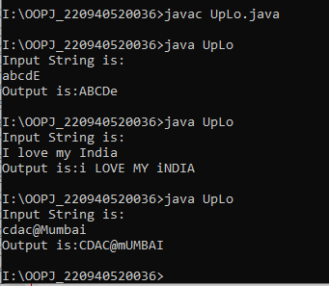

/*Question 2:

Write a Java Program for following Exception Handlers thrown by the code with given messages:*/

import java.util.*;

class MyException extends Exception

{

private int detail;

MyException(int a)

{

detail=a;

}

public String toString()

{

return "Myexception["+detail+"]";

}

}

class Division

{

static void solve(int arr[]) throws Exception

{

int ans=0;

for(int i=0;i<10;i++)

for(int j=i+1;j<10;j++)

ans+=arr[i]/arr[j];

throw new MyException(ans);

}

public static void main(String args[])

{

try

{

Scanner sc=new Scanner(System.in);

int n=sc.nextInt();

int []arr=new int[n];

sc.nextLine();

for(int i=0;i<10;i++)

arr[i]=Integer.parseInt(sc.nextLine());

String s=sc.nextLine();

System.out.println(s.charAt(10));

solve(arr);

}

catch(ArrayIndexOutOfBoundsException e)

{

System.out.println("Array Index is invalid");

}

catch(NumberFormatException e)

{

System.out.println("Format Mismatch");

}

catch(StringIndexOutOfBoundsException e)

{

System.out.println("Index is Invalid");

}

catch(ArithmeticException e)

{

System.out.println("Invalid Divison");

}

catch(MyException e)

{

System.out.println(e);

}

catch(Exception e)

{

System.out.println("Exception Encountered");

}

finally

{

System.out.println("Exception Handling Completed");

}

}

}

/*

Test case 1:

I:\OOPJ_220940520036>javac Division.java

I:\OOPJ_220940520036>java Division

10

10

9

8

7

6

5

4

3

2

1

exceptionhandlingtime

a

Myexception[117]

Exception Handling Completed

Test case 2:

I:\OOPJ_220940520036>java Division

9

1

2

3

4

5

6

7

8

9

string

Format Mismatch

Exception Handling Completed

Test case 3:

I:\OOPJ_220940520036>java Division

10

10

9

8

7

6

5

4

3

2

1

string

Index is Invalid

Exception Handling Completed

*/

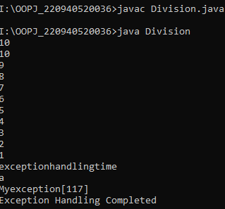

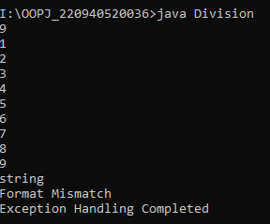

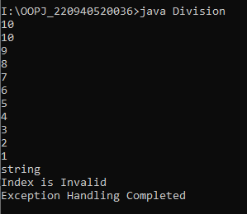

/*

Question 3:

Q3: Write a Java Program to implement the given inheritance with Shape is super class for Rectangle and Triangle class with

getArea() to calculate the area of rectangle and triangle.*/

class Shape

{

double height;

double width;

void setValues(double height,double width)

{

this.height=height;

this.width=width;

}

double getHeight()

{

return height;

}

double getWidth()

{

return width;

}

}

class Rectangle extends Shape

{

double getAreaRectangle()

{

double area=height*width;

return area;

}

}

class Triangle extends Shape

{

double getAreaTriangle()

{

double area=0.5*height*width;

return area;

}

}

class Area

{

public static void main(String args[])

{

Rectangle r1=new Rectangle();

r1.setValues(5.0,6.0);

System.out.println("Area of Rectangle is:"+r1.getAreaRectangle());

Triangle t1=new Triangle();

t1.setValues(8.0,9.0);

System.out.println("Area of Triangle is:"+t1.getAreaTriangle());

}

}

/*

O/P:

I:\OOPJ_220940520036>javac Area.java

I:\OOPJ_220940520036>java Area

Area of Rectangle is:30.0

Area of Triangle is:36.0

*/

